MAHATMA FULEY MSW AND MATOSHRI ZAVERIBEN MOTILAL TURKHIYA BSW COLLEGE, TALODA, DIST-NANDURBAR-425413,. MAHARASHTRA, (INDIA)
CSR CELL
Department of
Research & Extension Department
Project Director Project Co-ordinator
Prof. Usha B Vasave Prof. Nilesh U.Gaikwad
Acting Principal Assistant Professor.
Mb.no : 9423943488 Mb.no : 9011979284
Email id: socialnil_2007@rediffmail.com
socialnilesh25@gmail.com

Contact Details
Principal,
Mahatma Fuley MSW and Matoshri Zaveriben Motilal Turakhiya BSW College, Taloda, Dist-Nandurbar-425413
Website :www.csw.taloda.org.in
Principalcsw.taloda@gmail.com
Contact No : 02567-233643,44

MAHATMA FULEY MSW AND MATOSHRI ZAVERIBEN MOTILAL TURKHIYA BSW COLLEGE, TALODA, DIST-NANDURBAR-425413,. MAHARASHTRA, (INDIA)

Research & Extension Department
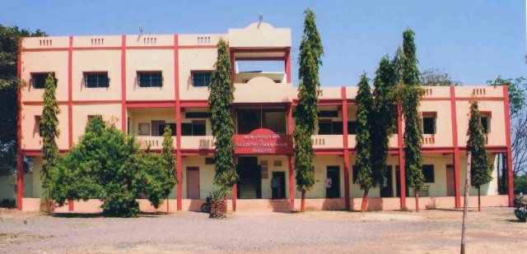
- About College :. By drawing inspiration from legendary work of Karmveer BhauraoPatil,(founder of Rayat Shikshan Sanstha) in the field of education in Maharashtra, Late. Principal G.H.Mahajan started an education institution in remote area of North Maharashtra region, namely, Taloda, 1971, under the umbrella of Adhyapak ShikshanMandal, Dhule.The very name of institute indicates it is not an institution for teachers, education but one that is being run by teachers themselves. His ideology states that as the tillers out to be the landlords, so teachers out to be that managers of the school. He devoted his whole life for education of the downtrodden and the disadvantage in general and tribal people in particular. The only College in three tahsil of Akkalkuwa, Taloda and Dhadgoan aimed at catering to the need of higher education for tribal people having a population of more than 65%. The sister college thus paved a way for ambitious school of social work envisaged through its constitution a decade ago.
- Our College affiliated with North Maharashtra University. We have two educational programmes like BSW (Bachelor of Social Work) and MSW (Master of Social work) with two specialization Generic course and Tribal welfare. More than 80% students are belong to Schedule tribe community. Field work is an integral practice of social work education for MSW AND BSW first year students enhancing their practice in institutional and welfare agencies and for MSW Second year students directly involved in open community for community organization and community development . also Research work is a prime task of social work education. Through by Research Consultancy and extension work, we are running academic, government and NGOs projects.

- Accreditation by NAAC, Bangalore:
The college of Social Work located at Taloda has been re-accredited with B Grade valid for five years. i.e. up to February 2019. Besides, it receives 100%Grant in aid from the Government of Maharashtra since 1995.
The Organization and Management :
AdhyapakShikshanMandal’s Arts and Commerece College Trust Registered under the Bombay Public Trusts Act 1950 (Registration No. E-247) IS THE EDUCATIONAL TRUST CONSISTING OF A General Board and a Governing Body formed as per, the provisions of memorandum of Association, its constitution. The Local Management Committee is also constituted as per the Maharashtra University ACT 1994. The Trust runs-
- A)Mahatma Phule MSW and MatoshriZaveribenMotilalTurkhiya BSW College, Taloda, Dist-Nandurbar.
B) C.H.Chaudhari Arts, S.G.Patel Commerce and B.B.J.Patel Science College, Taloda.
The MSW Course started in June 1980 received recognition from the Director of SOCIAL Welfare Maharashtra State, Pune vide order No.SSW/Recog.82-83/D-VI(B)/I dated 7th September,1982. The social work Department of the college was later on named after great social reformer Mahatma Phule.
The Mission of College:
“To train the rural and tribal youth for social study, diagnosis and positive intervention for shouldering the responsibility of well being and welfare of the disadvantaged and the vulnerable sections of the Society.”
- To Cater to the need of higher education of the masses in the Rural and Tribal areas of Nandurbar District.
- To Provide such insights and skills that will help in problem solving any field and development of leadership through community work and extension.
- To help students to acquire knowledge and skills through theory and practice of social work for effective handling of jobs or work in the field of social welfare and tribal welfare.
- Organizing co-curricular and extra curricular activities for all round development of the students desirous of making social work their career.
- To inculcate human values in education and strive for justice through Humanitarian and democratic processes.
- To address to the biological, social, cultural, psychological and developmental needs of the individuals, groups and communities by learning to use methods, tools and techniques of social work for rendering curative, correctional, rehabilitative, preventive and developmental services.
- To provide for studies of social problems, social legislation, welfare institutions Methodology of social work research, positive environmental action etc.
- To educate the community for increasing its well being through democratic Processes, environmental awareness, health education and social awareness.
- To serve as a well equipped center for social change, training and research.

- Concept Note :
Social work research deals with the application of research methods & skills in social work theory & practice in other word social work research aims at enhancing the knowledge base of social work and making the social work practice a scientific practiced by using various research methods, tools & techniques.
The college has constituted Research Cell for the coordination and Preparing project proposal to be submitted to the governmental and non governmental organizations. The cell decides the selection of field investigator, Supervisors or Assistant coordinator the amount of honorarium to be paid to students or faculty, the training programme to be organized for them are some of the areas of Cell recommendation or decision making.
The college has made available supportive facilities like a computer, printer a broadband internet connections and required furniture including a steel cupboard and chairs. The college encourage the faculty to undertake Research work.. They are also paid attractive honorarium for their contribution as Coordinator or Assistant Coordinator in carrying out evaluative research projects.
Objectives:
- To Study the Social Problems, their Effects on Society & to find out
Possible Solutions.
- To Undertake evaluative Research , to find out efficacy of
Governmental Schemes of Tribal development and Social Justice.
3. To Involve the Students in Research Activities & gain economic
benefit besides of field experience.
- To evaluate Programme Planning of reconstruction, empowerment &
Liberation.
- To explore social reality & explain social life.
- To Conduct Training and Competency building, Think Tank; Conferences and Seminar.
- Advocacy; and Research; Promotional Activities and Dissemination
- CSR Consultancy with strategic planning, need assessment, implementation and evaluative project work.

Project Advisory Body
- Project Patrons : Mr. Bharatbhai B. Mali (President, College Trust Taloda )
Mr.Narendrabhai Bhagwanbhai Patel.( Treasure, College
Trust Taloda )
- Project Director : Prof. Uha B Mali
- Project Coordinator : Prof. Nilesh U Gaikwad
- Legal Advisor : Adv. SandipPawar
- Health Expert : Dr.Mahesh More
- CSR executive : Dr.V.V.Kulkarni
- Experts : Prof.Jagdish Sonwane, Mr.Sandip Joshi, Dr.P.M.Vasave,
Dr.B.Arunkumar
Project Executive Body
- Project Director : Prof. Usha B Vasave

- Project Coordinator : Prof. Nilesh U Gaikwad

- Project Team Members :

Prof. N.W. Tayade
Prof. P. H.Jadhav
Prof. R.S.Pardeshi

- Field Investigators : Field worker and BSW and MSW Students
- Support Staff
- Office Superintend : Mrs. Leena P. Wani
- Accountant : Mr. S. K. Patel
- Computer Operator : Mr. Rakesh S. Amrutsagar
- Library Support :Mr. Murlidhar Chavhan(Support Staff)
- Support staff : Mr. Dhananjay Sonawane
Mr. Gulab Sandanshiv
Mrs. SulochanaPadavi

Mahatma Fuley MSW and Matoshri Zaveriben Motilal Turakhiya BSW College, Taloda, Dist-Nandurbar
Research and Extension Department
Sr.no | Name of the Organization | Project Name | Students Involvement | Duration | Total Amount | Coordinator | Project completed
1 | Scvens Technology, Nasik | Skills Development | 60 | 5 months  January 2024 to May-2024 | Providing free training to the students | Prof.R.S.Pardeshi  Prof.Nilesh U Gaikwad | Yes
2 | Sub District Hospital, Taloda, Dist-Nandurbar | Survey of Leprosy and awareness campaign | 20 | 1 month  29 January 2024 | Voluntary base work | Prof.R.S.Pardeshi  Dr.P.H.Jadhav | Yes
3 | Indian Gramin Service, Nandurbar | Baseline Survey And PRA | 20 | January to February 2024 | 116000/- | Prof.N.U.Gaikwad  Prof.R.S.Pardeshi | Yes
4 | Social Responsibility Asia (SR Asia) | Evaluation Survey | 06 | July 2023 | 16000/- deposited to four Volunteers | Prof.N.U.Gaikwad | Yes
5 | ASER, Mumbai | Survey of Zillah Parishad School, Nandurbar | 60 | September 2022 | 57000/- | Prof.N.U.Gaikwad | Yes
6 | MDL, Mumbai | CSR-Monitoring Project, Nandurbar | 04 | 2020 to 2022 | 9,49,000/- | Prof.N.U.Gaikwad | Yes
7 | AIF, Delhi | LAMP Project,Survey of Zillah Parishad and Ashram school, Nandurbar | 60 | 2020 to 2021 | 1,60,600/- | Prof.Ramchandra Pardeshi  Prof.Nilesh U Gaikwad | Yes
8 | Nirmala Niketan college of social work , Mumbai | Students Exchange Programme | 60 | February 2021 | Voluntary Micro study of village and visits | Prof.Nilesh U Gaikwad  Prof.Nitin W Tayade | Yes
9 | ASER, Mumbai | Online Survey of Zillah Parishad School, Nandurbar | 60 | September 2021 | 6000/- | Prof.N.U.Gaikwad | Yes
10 | Nirmala Niketan College of Social Work, Mumbai | Rural-Urban Learning Exchange for Development | 240 | 19/02/2021 to 21/02/2021 | Field action Students Learning Project | Prof.Nilesh U Gaikwad  Prof.Nitin Vasudeo Tayade | Yes
11 | Dilasa NGO, Pune | ITC Baseline Survey | 50 | March 2019 to October 2019 | 38,000/- | Prof.N.U.Gaikwad | Yes
12 | Tribal Research and Training Institute, Pune | Selection of Coordinator in Benchmark Survey | 60 students for interview | August 2019 | 13250/- | Prof.D.M.Mali  Prof.Nilesh U Gaikwad | Yes
13 | Piramal Foundation, Nandurbar | Assessment of educational project of Z.P.School, Nandurbar | 60 | October 2019 | Voluntary based online work | Prof.N.W.Tayade | Yes
14 | Loksamanvay Pratishthan, Taloda, and ITDP, Taloda, Dist-Nandurbar | Micro planning and Management Design Project of Forest Dwellers | 60 | 30 October, 2019 to November 2019 | 30 students participated honorarium deposited to direct students account | Prof.Nilesh U Gaikwad  Prof.R.S.Pardeshi | Yes
15 | Meljol, Mumbai | Testing educational tools for Zillah Parishad and Ashram School, Taloda | 240 | 2018 to 2019 | Filed action Students Learning Project | Prof. Usha B Vasave  Prof.Nilesh U Gaikwad | Yes
16 | Tahsil office, Taloda, Dist-Nandurbar | Social Audit of Employment Guarantee Scheme Project | 60 | January 2018 to February 2018 | Total 65 students Per day 200 rupees. | Prof.N.U.Gaikwad | Yes
17 | ASER, Mumbai | Survey of Zillah Parishad School, Nandurbar | 60 | September 2018 | 49000/- | Prof.N.U.Gaikwad | Yes
18 | Sub Distict Hospital , Taloda, Dist-Nandurbar | Survey of Leprosy | 50 | October 2018 | 28000/- Directed deposited to students account | Prof.R.S.Pardeshi | Yes
19 | Data mention Agency, Delhi | Online Evaluation survey of Sarva Shiksha Abhiyan, Dist-Nandurbar | 30 | September 2017 | 6517/-  Directed deposited to students account | Prof.N.U.Gaikwad | Yes
20 | National Child Labor Project, Nandurbar | Survey of Child labor in Nandurbar District | 30 | September 2017 |  | Prof.Nitin Tayade | Yes
21 | UNICEF- Child Friendly Project, Z.P.Nandurbar | Survey of three villages, formation of child friendly group and conducted activities | 12 | September 2015 | 57156/- amount directly deposited to students account | Prof.A.T.Wagh  Prof.Nilesh U Gaikwad | Yes

Community Extension Work :
- Celebrated Social justice day on the occasion of Birth anniversary of Chatrapati Rajshri Shahu Maharaj at college level as well as community level.
- Har Ghar Tiranga National Integrity awareness created in respective villages and college level during 07 August 2023 to 15 August 2023
- Celebrated World Tribal Day at college level as well as community level during 07 August to 09 August 2023.
- Divyang Abhiyan programme initiative taken by college with collaboration to Social Welfare Department, Government of Maharashtra.
- On dated 29/9/2022 Established Reading Platform at Zillah Parishad School, kothar village .Block- Taloda, Dist-Nandurbar.
- Created Election Awareness campaign to villages level by street play and posters.
- During Covid-19 our social work students involved and creating awareness on Immunization in their village level (2020-2021)
- Conducted Child health and Malnourishment survey at Dhadgaon and Taloda block by Piramal foundation , Mumbai.
- Organized Tree Plantation Programme in respective field work villages as well as in college campus.
- Celebrated Personal Hygine and sanitation programme at villages and Ashram schools, Zillha Parishad government school.
- Creating awareness campaign programme on HIV / AIDS at college and community level and establish Red Ribben club at college level.
- Created Child health and maternal health awareness programme through by street play in respective field work villages.
- Every year conducted Practical PRA Workshop at village level and identify village problems and needs and helping to the village development plan.
- Organized Gender sensitization and sexual health education programme for ashram school students and social work students.
- Created awareness and provided social education towards open depiction supported by NSE Foundation.

Upcoming Project will carried out by Research and Extension Cell

- Organic Kitchen Garden Project – (Proposal Completed)
- Women empowerment through skill Training - (Proposal Completed)
- Youth Development through skills Training - (Proposal Completed)
- Child Health, Malnourishment and Maternal Health Project - (Proposal Completed)
- Project Proposal for Digital Computer Lab.
The following are the socio- economic problems of the Tribals in Nandurbar District:

1 . Problems Related to Forests: In the forests, STs lived, enjoyed hunting, gathering and shiftingcultivation and artefacts made from forest-material. But forest policies and regulations have snatchedaway traditional rights of STs over forest. Due to this, economic activities of tribals like food gathering, hunting, shifting cultivation and cottage industry have been affected adversely. It has brought thequestion of existence before a number of tribes living in forest based economy.

2. Problem of Agriculture: Some tribals practice agriculture and are known as agricultural tribes such asMunda, Oraon, Ho, Santhal. etc. Agricultural lands of tribals are located near the hills or at foot hills andforests. Lands cultivated arc known as Arc Don (Downland) and Tanr (Upland). In Downland good variety of paddy are cultivated by wet cultivation method. But in Tanr land maize, mille, maruaarahar, Tisi, Mustard, etc. are sown by dry cultivation method. There is no assured means of irrigation. Socultivation of Rabbi crops and Garma crops is negligible. In this way, agriculture do not provide thememployment round the year. It also does not provide sufficient food for the family round the year.Agricultural crops are sometimes destroyed by wild animals.

3. Land Alienation: From the British days, the tribal lands have been acquired for road, railways, offices,colonies, market, hospital, post-office, etc. The outsiders, contractors and money lenders have alsopurchased lands of tribals. Marriage of tribal girls with non-tribal also resulted in land alienation. Richtribals are also purchasing the land of poor tribals. In this way, land alienation has resulted in landlessness among tribals.

4. Indebtedness and Bonded Labor: Earning daily wages are only means through which a good number oftribal families are surviving today. But as laborers, they do not get work round the year and thepayment is neither regular nor proper. As a result, a majority of them are not in a position to meet bothends . Naturally, they have to take loan from landlords at a high rate of interest. When they expressinability to repay their loan and interest, they are made to repay it by working as bonded labor at nominal wage.

5. Problem of Health and Nutrition: Through the practice of food gathering and hunting, tribals were able to get nutrient like Vitamins, Minerals, Protein, Carbohydrates, etc. But ban on hunting andgathering coupled with the depletion of forests has resulted in malnutrition and under-nourishment. Theincome of majority of tribal families is not enough to feed family members properly. This keeps them inthe state of semi-starvation. The environment in which they live is also unhygienic. These affect theirhealth adversely. They visit the local traditional healers for seeking cure of their ailments. Lack ofmoney does not allow them to visit private hospitals and public hospitals are away from their places.

6. Lack of Communication: The tribals live in remote areas. Hence, one has to face a great problem ofcommunication. It takes much time for news related to welfare and development to reach them. As aresult, they are not conscious of their rights and ignorant of a number of development schemes.

7. Migration and Its Effects: The STs have to migrate at different places inside the State or outside theState for work and wages. They go to work at construction sites, brick kilns, small industries, agriculture,etc. As migrant labor, they are exploited and oppressed. They do not get wages as per the MinimumWages Act, revised by the Government from time to time. They have to work for long hours.

8. Lack of Education: A good number of tribal families have to struggle hard to maintain their existence.For them, bread is more important than education. The Government has opened Ashram Schools forthem. But it has not been possible to enroll their children. Enrolled children too have to work in theirhouses, adding to the problem of absenteeism and dropouts from the schools. The case of femaleilliteracy is more acute.

9. Displacement of Tribal’s: STs have to face the problems of displacement for the establishment of majorindustries, thermal power stations and hydraulic projects. After such displacement, even thoughcompensation is given to them, in reality, majority of them have not got such compensation. In this way, the displaced tribal’s lead their dismal life in slum areas of the cities.

10. Problems of Migration and unemployment.

11.Lacking of People participation in developmental work.

12.Women Issues

13. Adolescents girls and boys problems

14. Addiction and health problems

15.Poverty & Low socio-economic status: Poverty is a leading factor of tribal due to the poor financial conditions tribal’s are not full fill their adequate needs. Majority of tribal working in unorganized sector with their children.

16. High illiteracy rate: due to the ignorance and not serious about education and poor financial condition. tribal.s are mainly focused on livelihood not education. High drop out rate during and after primary education means secondary education.

17. Migration: is a leading factor of tribal’s so that for livelihood purpose they are migrated to the out of state like Gujarat, Madhya Pradesh, etc so all family are migrated for agriculture work because of that their pupils not taking proper education in schools. Girls are more vulnerable groups to serve in household work and agriculture work so that tribals girls has high drop rate in school during and after primary education.

Project Themes to be implemented with the assistance of TRTI, PUNE
- “ A Study of Knowledge on Sexual Health Education among Adolescent tribal Girls Studying in Ashram School with Special reference Nandurbar District.
- Educational Problems among tribal’s in Nandurbar District.
- .Rural Women Entrepreneur & Entrepreneurship: Challenging aspect
- Self Help Groups of Empowerment of the Tribal Women.
- Socio Economic Problems Of Scheduled Tribes
- Impact of Irrigation on Agricultural Productivity in Nandurbar District
- Best Practices for Tribal Development.
- Socio-economic and cultural changes among tribal’s in North Maharashtra Region. of Nandurbar district.
- 0-6 years Tribal Children raring and caring practice in Nandurbar district
- Evaluative research on tribal schemes and programmes for Nandurbar District
11 Health Care Services: A Major Problem of Tribal People in Nandurbar District of
Maharashtra.
12. Role of Panchayat Members in tribal Development.

1. Project Director Project Co-ordinator

Prof. U.B.Vasave Prof. Nilesh U Gaikwad

About Nandurbar District :
History

Before 1st of July 1998 Nandurbar was part of the larger Dhule district. Nandurbar, Dhule and Jalgaon districts formed what was known as the Khandesh district. Dhule was known as the west Khandesh whereas Jalgaon was known as the east Khandesh. So, much of history applicabe to Khandesh and Dhule, is applicable to Nandurbar.
Prior to 1906 Dhule, Nandurbar and Jalgaon district were together known as Khandesh. According to some followers khandesh means the country of Lord Krishna. In the year 1906 from administtrative point of view khandesh district was bifercated in two districts namely East khandesh and West khandesh having Jalgaon and Dhule as district places respectively. Later on the names of East Khandesh and West Khandesh district have been changed as Jalgoan and Dhule District respectively, Further on 1st July 1998 Dhule District was bifercated in two district namely Dhule and Nandurbar. Nandurbar is also known as Nandanagri as the king Named Nandaraja was the ruler of this territory.

District Location :
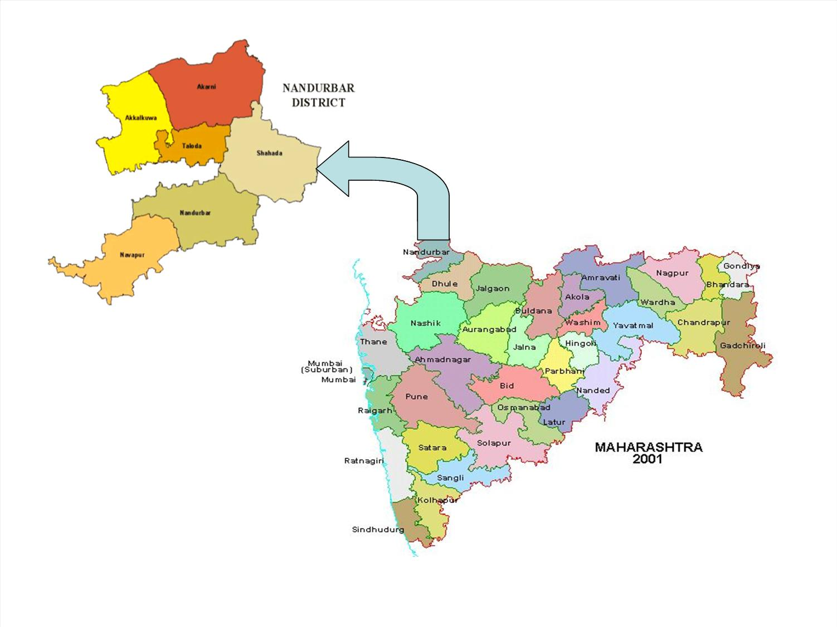
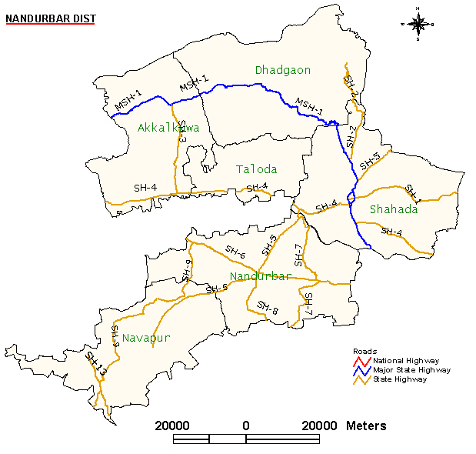
The district comprises 6 talukas. These talukas are Akkalkuwa, Akrani Mahal (also called Dhadgaon), Taloda, Shahada, Nandurbar and Navapur .
There is one LokSabha constituency in the district which is Nandurbar (ST) reserved for ST. There are four Maharashtra Assembly seats namely Akkalkuwa (ST), Shahada (ST), Nandurbar (ST), Nawapur (ST).
Sakri (ST) and Shirpur (ST) assembly seats from Dhule district are also part of NandurbarLokSabha seat. Nandurbar is primarily a tribal (Adiwasi) district.

Demographics

As of 2001 India census,[3] Nandurbar District had a population of 1,311,709., being 50.62% male and 49.38% female. Nandurbar District has an average literacy rate of 46.63%, : male literacy is 55.11%%, and female literacy is 37.93%.
Languages/Dialects:

Ahirani
Bhili
Pardhi
Marathi
Hindi
Gujari.

District Details

Nandurbar is located in North western side of Maharashtra State. The District Head Quarter of Nandurbar District is Nandurbar. Nandurbar district is bounded to the south and south-east by Dhule district, to the west and north is the state of Gujarat, to the north and north-east is the state of Madhya Pradesh. The northern boundary of the district is defined by the great Narmada river.

Geographical Details:
Area | 5034 Sq. Km.
Location | 21.0 to 22.03 North axis 73.31 to 74.32 East axis.
Main Rivers | Tapi, Narmada
Climate | Dry
Rainfall | 859 mm
Adjoining States | Gujrat, Madhyapradesh
Adjoining Districts | Dhule From Maharshtra

Transport and Communication

 | Total railway Lines length : | 90 km
 | No of Villages Connected by road : | 12 Months :671 Temporary :262
 | Total length of the roads : | 4338 km
 | Total length of National Highway : | 44 km
 | Total length of State Highway : | 611 km
 | Total length of Major District Roads : | 948 km
 | Total length of Other District Roads : | 672 km
 | Total length of Village Roads : | 2063 km

Agriculture

Main Crops Jawar, Wheat, Rice, Toor, Groundnuts, Chilly .
Annual Crops Sugarcane, Cotton.
Area Under Cultivation :2,53,413 Ha.
Crop Pattern Kharif (approx. 800 villages), Rabi (approx. 130 villages) .
Fruits :Mango, Sitaphal, Banana .
Climate

The Climate of Nandurbar District is generally Hot and Dry.
Summer is from March to mid of June. Summer season is usually hot and dry. During the month of May the summer is at its peak. Temperatures can be as high as 45 degree Celsius during the peak of Summer. The Monsoon sets in during the mid or end of June. During this season the weather is usually humid and hot. The northern and western regions receive more rainfall than the rest of the region. The average rainfall is 859 mm through the district. Winters are mildly cold but dry.

Seasons | Start | End
Summer | March | Mid June
Monsoon | Mid June | October
Winter | November | February
DISTRICT LEVEL FORECAST
Religion

Prakasha, one of the famous religious place, also known as DakshinKashi, is in Shahada Tehsil.
One of the famous temple of God Shree Ganesha (Heramb) is at Jaynagar, 24 km away from Shahada. Thousands of people visit this temple on the occasion of MangliChathurthi.
ShriDatta temple is at Sarangkheda. Every year a big fair is organised on the eve of DattaJayanti. Horse Bazar at the time of DattaJayanti is famous in the Country.
Astambayatra in AkraniTahasil religious places is also in this district.
Dandapaneshwar Ganesh Mandir.

Other notable places in Nandurbar District

Toranmal is the second coolest hill station in Maharashtra state and is near Shahada (approx. 40 km). It is the second highest place in Maharashtra. It has a natural lake called Yashwant Lake which is natural and full of flowering lotus. It is a good place for sight-seeing and picnic.
Unapdev (25 km from Shāhāda) is a pleasant picnic point in Shahada tehsil. It has a permanent natural hot water source, and it flows throughout the year from a structure in the shape of a cow's mouth.

************************************************************************

